Health Insurance Cost Analysis

Submitted By:
DEVANSH GROVER - 2423366
SHAURYA BAJAJ - 2423374
AAKARSH JAWA - 2423380

Introduction
The objective of this project is to analyze the factors affecting medical insurance charges using regression analysis. Insurance companies rely on data-driven models to determine premium pricing and risk segmentation. This study uses a dataset of 1,338 policyholders to identify key drivers of insurance cost.

Business Objective
The main objective is to determine which demographic and lifestyle factors significantly influence insurance charges and quantify their impact using statistical modeling.
Dataset Overview
The dataset contains 1,338 observations with the following variables:
Age
Sex
BMI
Number of Children
Smoking Status
Region
Insurance Charges (Target Variable)

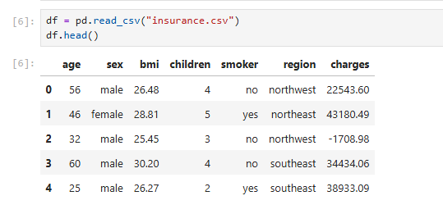

Exploratory Data Analysis (EDA)
- Summary Statistics - The average insurance charge shows high variability. BMI values suggest a relatively high average body mass index. Age ranges from young adults to senior individuals.
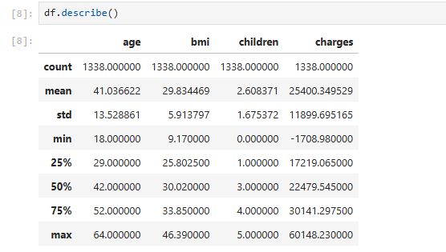
- Correlation Analysis - Correlation analysis shows positive relationships between age, BMI, and insurance charges. Smoking status shows the strongest visible impact.
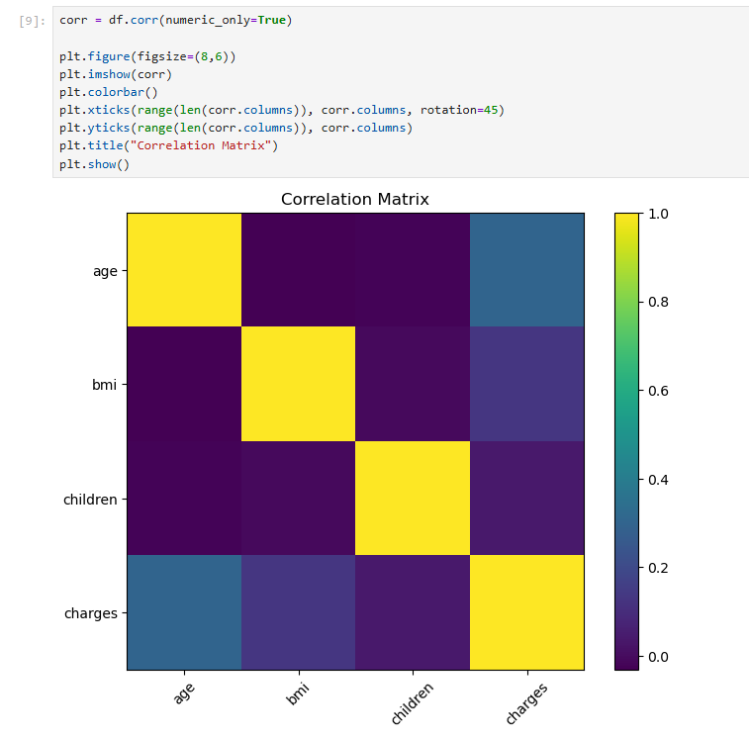

- Smoking Impact - Smokers incur significantly higher insurance charges compared to non-smokers, indicating lifestyle risk plays a dominant role.
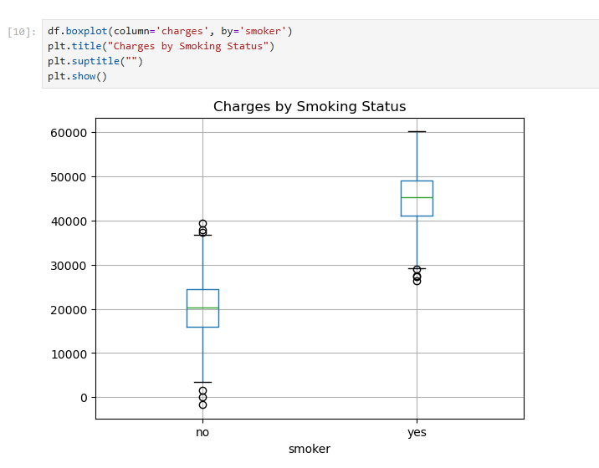

Regression Model
An Ordinary Least Squares (OLS) regression model was developed to quantify the relationship between predictors and insurance charges.

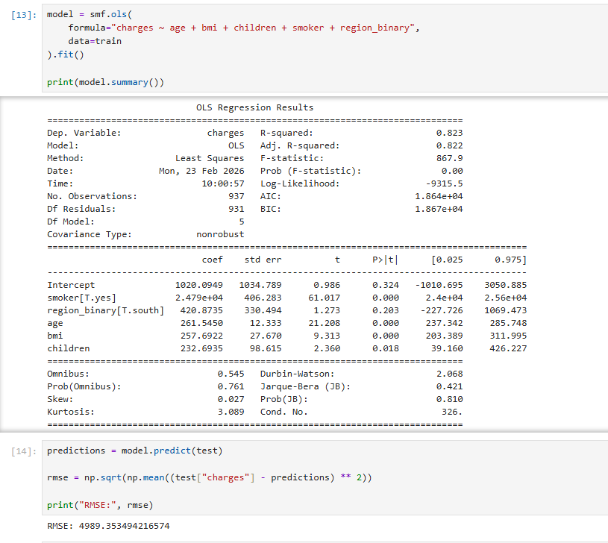

Model Performance
R² = 0.823
Adjusted R² = 0.822
RMSE = 4,989
The model explains 82.3% of the variance in insurance charges, indicating strong predictive performance.

Interpretation of Coefficients
Smoking increases charges by ₹24,790 (highly significant).
Each additional year of age increases charges by ₹261.
Each BMI unit increases charges by ₹257.
Each additional child increases charges by ₹232.
Region was not statistically significant.

Business Implications
Insurance companies should apply significant premium differentials for smokers. Age-based premium laddering and BMI-based wellness programs can help manage risk exposure.

Limitations
The dataset does not include medical history, chronic disease information, or healthcare usage frequency. Therefore, some variability remains unexplained.

Conclusion
This study demonstrates that smoking is the dominant predictor of insurance charges, followed by age and BMI. The regression model provides strong explanatory power (R² = 0.823) and can be used for risk-based pricing and strategic decision-making.

